Year 7 Science: At a stretch – Cup Stack Challenge
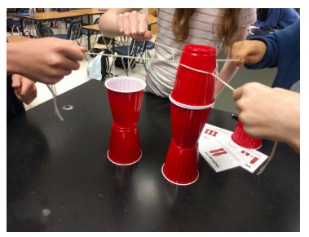

Aim: to explore how forces from different directions can be used to move objects.
Materials: (per group)
- 6 x plastic cups
- 1 x rubber band
- 3 x pieces of string (one piece per person)
Method:
- Get into groups of 3- 4 students.
- Stretch the rubber band over the base of one of the cups.
- Loop the pieces of string around the rubber band at equal distances from each other.
- Each group member holds a piece of string and pulls in their direction. The groups must try moving a cup just by pulling the string, without using their hands. Practice moving a cup as team.
- Re-stack all the cups in single pile upside down and try to complete the first challenge by moving each of the cups. Remember you can only pull the string; you cannot use your hands.
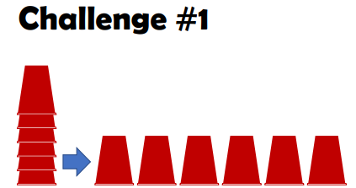
- Restack the cups and try to complete the second challenge.
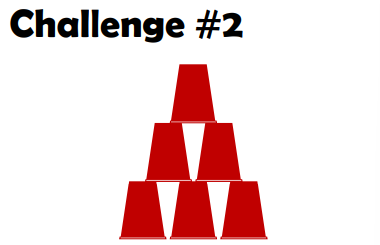
- Restack the cups and try to complete the third or fourth challenge.
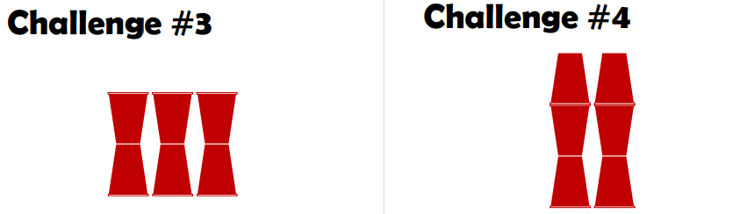
- Restack the cups and put away the materials.

Discussion questions:
- How many of the challenges was your group able to complete?

- What forces are acting on the cup as it is being moved? Try to include the directions of each force in your answer.

- Explain why did the cup move in one direction when all team members were pulling in different directions?

- Explain how different people had to pull their string pieces to get the cups to move in a direction.

- Explain how different people had to pull their string pieces to get the cups to move in a constant speed or motion.

- Complete the diagram below of the cup being moved by showing the pulling forces acting on it when it is being moved in one direction.

Conclusion: What have you learnt about forces acting in different directions? How do they act to move things?

